IERG1000 LAB REPORT 1

NAME : YU MU QUAN, SID : 1155191596, Email : [ym022@ie.cuhk.edu.hk](mailto:ym022@ie.cuhk.edu.hk)

### Task 1.1

Run at server VM ¶

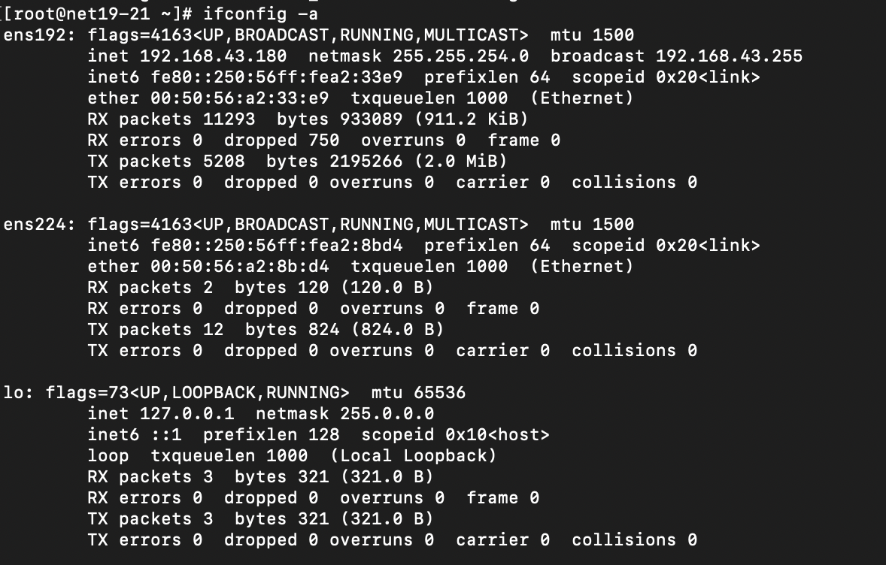

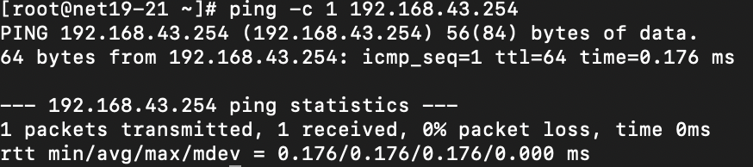

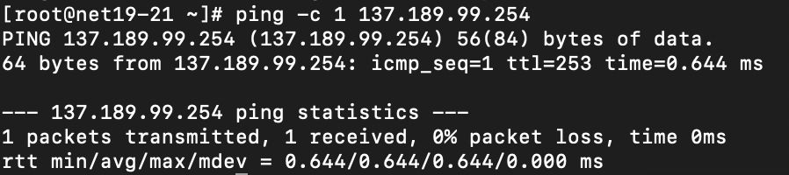

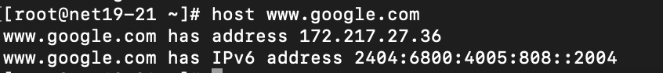

### Task 1.2

Run at client VM ¶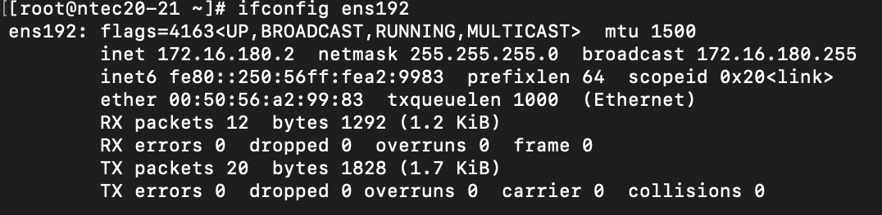

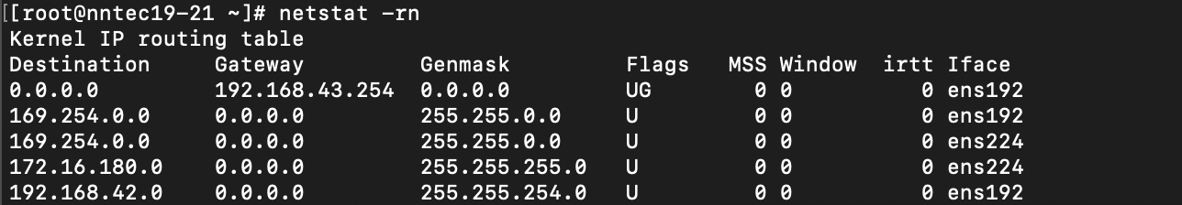

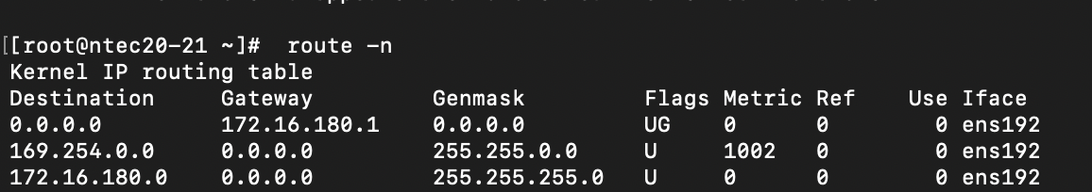

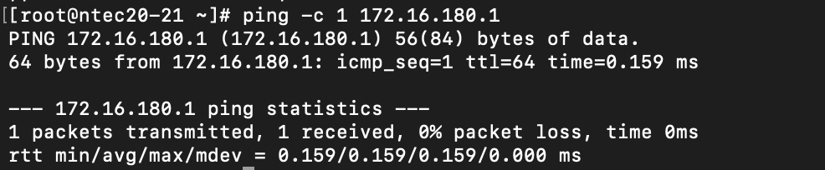

Run at Server vm ¶

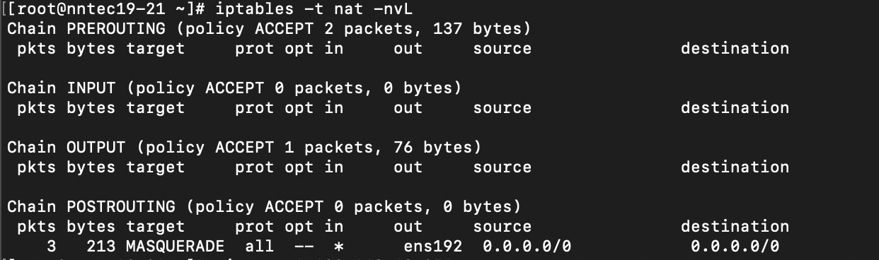

Run at Client VM¶

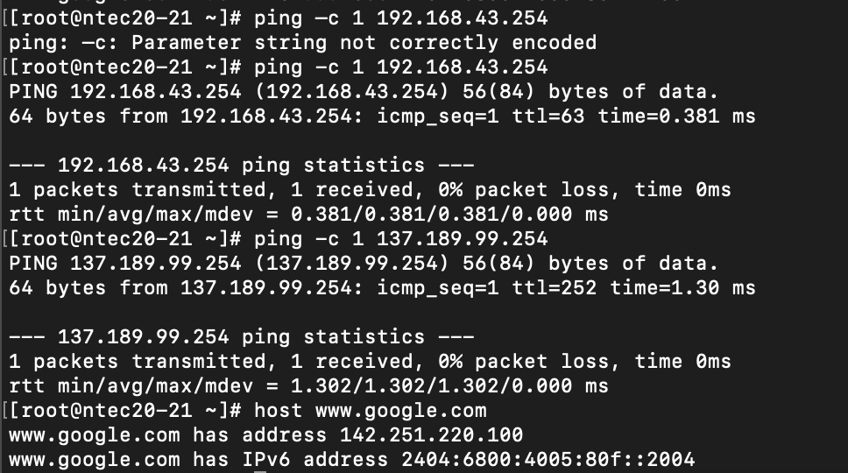

### Task 2.2¶

At the Client VM, show the content of ~/.ssh/authorized_keys



### Task 2.3

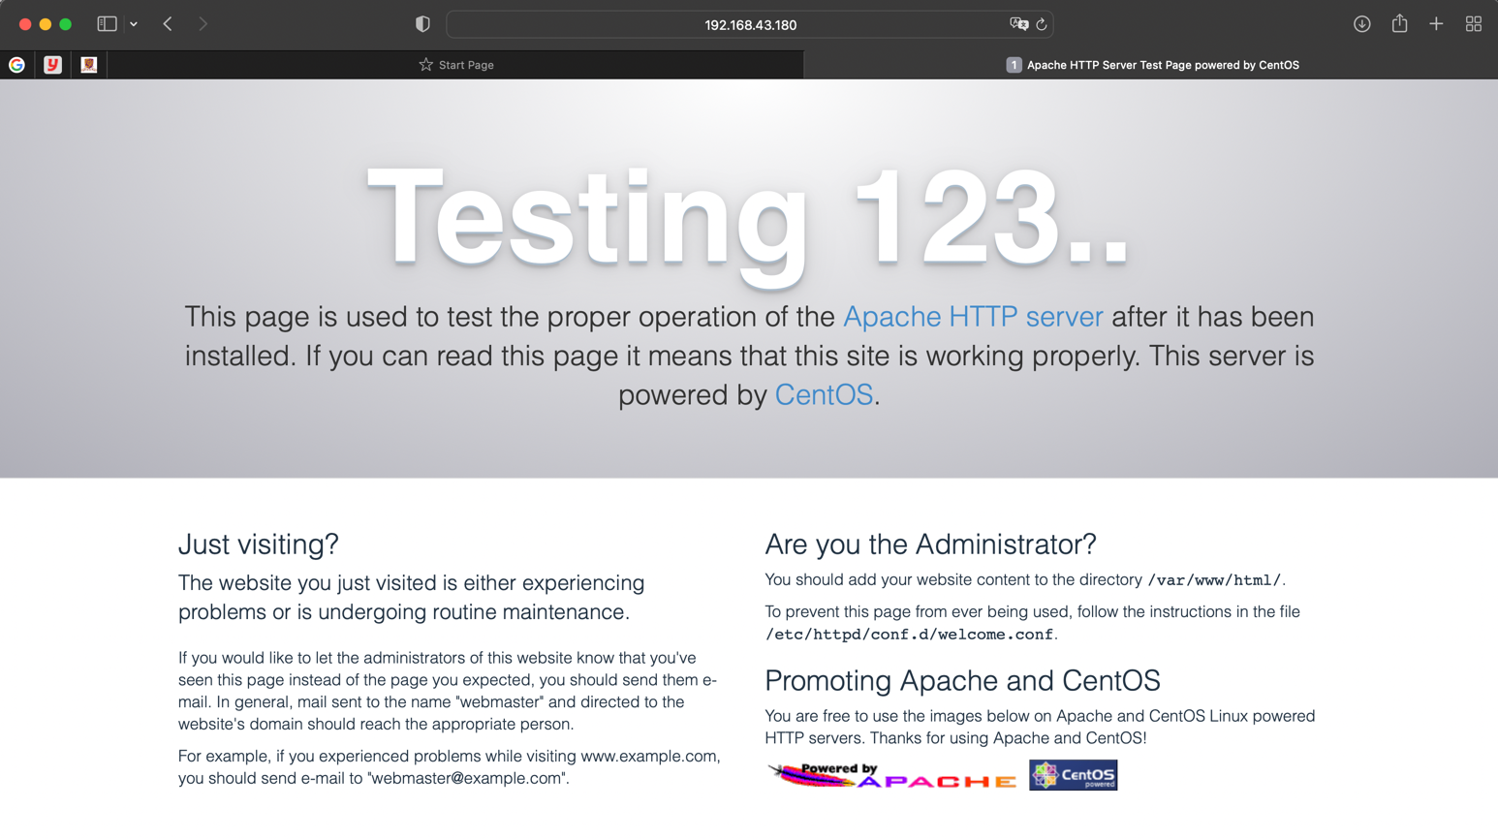

### Task 2.4

At Client VM¶

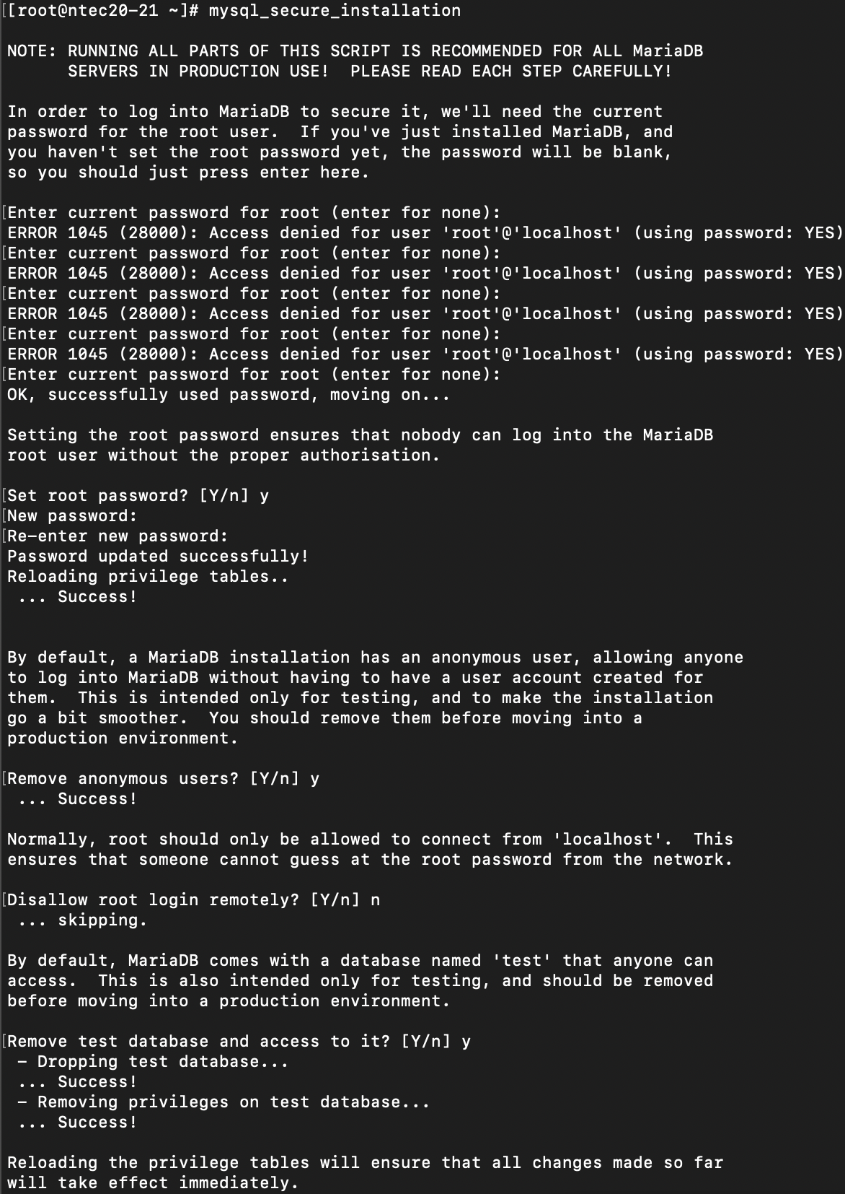

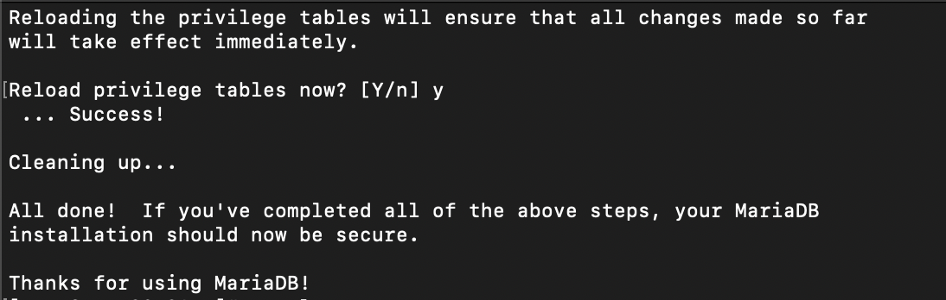

At Server VM¶

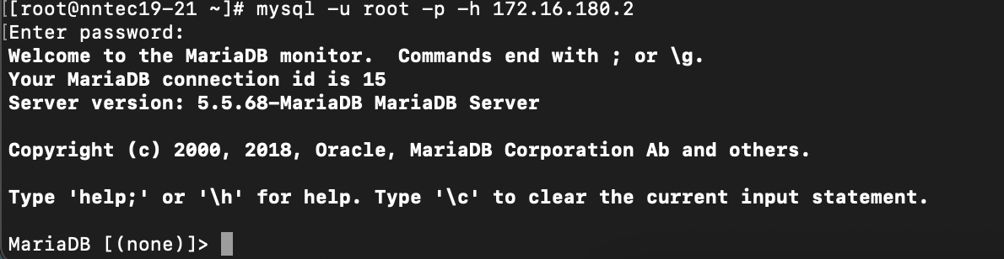

### Task 2.5

Login : root, password : cuhk1234

